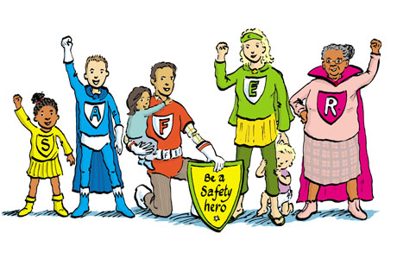
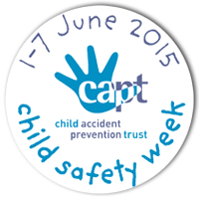

Summer Water Safety for kids
Wiltshire Primary Schools Water Safety Super Hero Poster Competition
Useful information for teachers ( two pages)

In and around the home | Swimming pools
Key issues  - Babies & young children are at greater risk and need constant adult supervision in and near water  - Baths – empty immediately after use  - Paddling pools – empty after use  - Ponds – little children need to be supervised near a pond, by an adult  - Buckets/water butts– empty or use secure lids | Key issues  - More children from the UK, drown in hotel and villa pools abroad, in the first hour of arriving.  - No barrier or gate between pool and surrounding area creates an additional danger to young children  - Private pools without a lifeguard mean adults should be extra vigilant  - Follow pool rules  - Check the depth of the water in the pool  - Don’t dive in the shallow end  - Non swimmers need buoyancy aids  - Adult supervision is important and  alcohol and swimming don’t mix
The beach and sea | Open water - Rivers, canals, reservoirs, quarries and lakes
Key issues  - Swim at a lifeguarded beach, when possible  - Check the flag system on beach  - Swim between red & yellow flags  - Be careful not to get out of your depth  - Watch out for rip currents in the sea, they can pull you under  - Wear lifejackets on boats, jet skis and for other water activities  - Inflatables in the sea, can quickly pull you out of your depth, with the wind and tides  - Jumping/tombstoning into sea from rocks, cliffs and piers is dangerous  - Look at tide times and prevent getting cut off on the beach  - Always swim with others  - Adult supervision is important | Key issues  - Open water stays cold, all year round  - Cold water shock, affects our ability to swim and self rescue  - Stay back from the edge of the water bank, as it can be slippery & unstable  - Swim in lifeguarded lakes  - Get out of the water as soon as you begin to feel cold  - Always take someone with you when you are in or near open water  - Wear a lifejacket on boats  - Jumping in or tombstoning is dangerous  - Beware of underwater hazards  - River weirs have undercurrents- don’t walk across or swim near them  - Don’t swim if you have been drinking alcohol  - Know who to call in an emergency  - Adult supervision
The SAFE code  S – Spot  Spot the dangers  A – Advice  Follow safety signs and advice  F – Friend  Stay close to a friend or family member  E – Emergency  Shout for help and know the emergency numbers at home and abroad | Useful links  Royal Life Saving Society UK  www.rlss.org.uk/watersafety  Royal National Lifeboat Institute  www.rnli.org/safetyandeducation  The Angus Lawson Memorial Trust  www.almt.org/the-danger-age-video  Child Accident Prevention Trust  www.childsafetyweek.org.uk  Royal Society for the Prevention of Accidents  www.rospa.org.uk

